Hector Pena
DSC 680
Bellevue University
Cardiovascular Health Analysis
Business Problem:
With the rising health concerns in the United States, this project will take a deep dive into how certain individuals meeting certain body criteria may or may not have a higher risk for heart disease and or a heart attack. This data can then be used to educate individuals to change their lifestyle to live and longer and healthier life. An analysis that emphasizes the health concerns related to the cardiovascular health of individuals to see if there are any similarities between certain individuals with similar lifestyles in relation to heart health. In this project we will look at cardiovascular health from many different patients to determine if there are any patterns in those individuals who have experienced a heart attack versus those who have not.
Background:
Heart health in the United States has evolved dramatically over the last century, the timeline includes major shifts in disease patterns, scientific discoveries, lifestyle changes, and medical technology. Today heart disease is still the leading cause of death in the U.S., but death rates have dropped significantly since the mid-20th century due to research and prevention efforts. In the early 1900’s the leading cause of death was infectious diseases such as tuberculosis and influenza. As vaccines and antibiotics improved individuals lives longer which revealed more chronic illnesses like heart disease. Between the 1920’s and 1930’s heart disease began to rise rapidly, but doctors had limited tools for diagnosis.
Shifting to between the 1940’s and 1960’s this is seen as a turning point as large population studies were ran. One of these studies being the Framingham Heart Study, started in 1948, this study followed thousands of residents for decades to identify risk factors for cardiovascular disease. The key discoveries consist of issues like high blood pressure, high cholesterol, smoking, obesity, lack of exercise, and diabetes. The research from this study helped create the topic of “risk factors”.
Moving to between the 1960’s and 1980’s the United States government and organizations like the American Heart Association launched educational campaigns, these campaigns provided warnings about smoking and heart disease becoming widespread. Guidelines for nutrition were encouraged, these guidelines helped lower saturated fats, lower cholesterol, and encouraged more fruits and vegetables intake. Medical Advances were seen to improve between this era shifting into the 1990’s and 2000’s the advancements in medical technology have allowed for bypass surgery, intensive care units, as well as early heart transplants.
Early 2000’s presented a new challenge, despite medical technology progressing issue lifestyle factors of individuals proved to cause heart health to suffer. Changes in obesity patterns and lifestyle showed a rise poor heart health. The introduction of wearable health tech items to help monitor health and heart patterns have showed improvements in individuals.
Data Explanation:
The data for this project has been collected from Kaggle, this dataset has 17 different metrics that range in category. This dataset helps us see metrics such as Patient ID, age, BMI, daily steps, etc. With these types of metrics, we can show the public what warning signs to look for to avoid or to help reduce cardiovascular disease. To get the most of our data we must perform basic EDA to remove any irregularities in our data as well as fill any null values that may be in place. We will also filter our data to segment it by columns so we can get a closer look at certain metrics.
Methods:
With this dataset we have a wide range of potential type of analysis, with these metrics we can run a heart disease risk prediction model to help individuals predict if they are at risk for heart disease. We can also run a feature importance analysis to highlight which metrics are the most important to keep a good heart health. With the use of medical ML classification and regression modeling we can help create a classification and regression model to help doctors classify their patients into at risk, low risk, or no risk. Finally, we can run a health analytics study to deep dive into patients’ health to see if there are any underlying markers for heart health.
Analysis:
After running EDA and the methods listed above we can see the distribution of our data, we can see an even spread of ages amongst patients, while slight peaks at the ages 20, 30, 40, 50, etc.
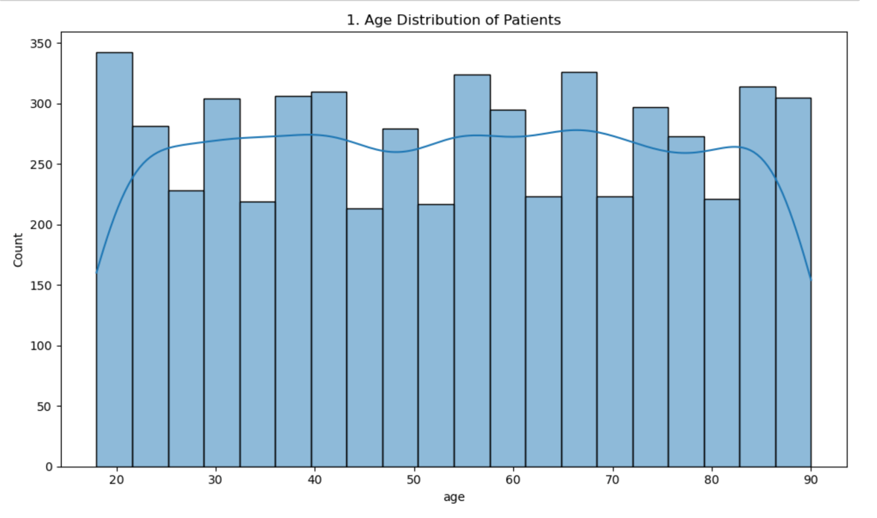
We can see an influx at the top of each decade of age ranges and at the age of 20 there is a highest count of patients.
Secondly we can see the distribution of Body Mass Index (BMI) of patients, this index measures the amount of body fat based on height and weight that applies to adult men and women. In this distribution we can see a normal curve with majority of patients landing between 25 and 33 on the BMI scale.
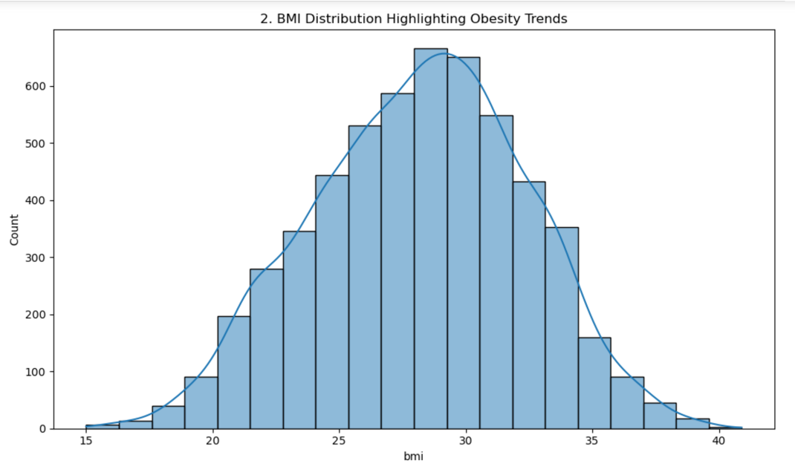
Shifting to the question of history of heart disease in the family, we can see that most of our patients have recorded a history of heart disease in their family.
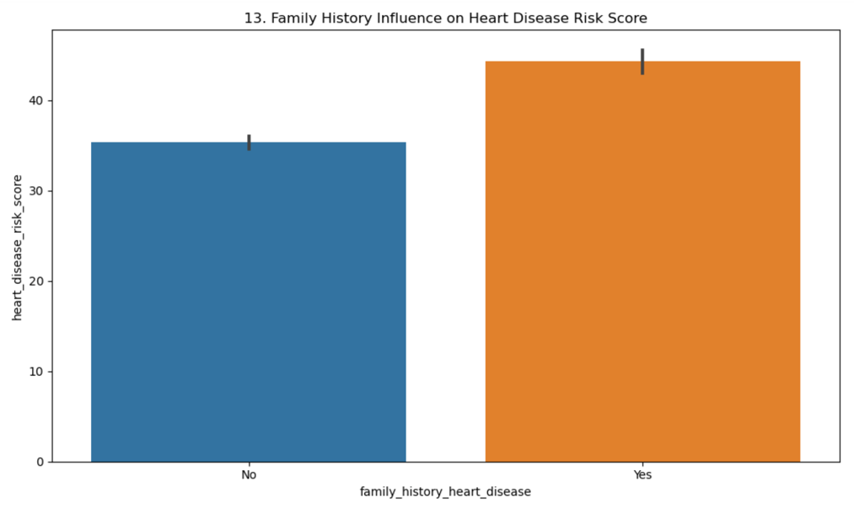
Looking at a logistic regression model, dropping patient ID and splitting the data into test and train sets, we get a model accuracy rating of 0.9755, showing us that with the metrics in this dataset we can confidently predict if an individual is believed to have heart disease based on the metrics provided.

Conclusion:
We can see from the metrics in this dataset that heart health and risk of heart disease have to do with many factors. Us as individuals must consider our stress levels, amount of sleep, and lifestyle choices when thinking of our heart health. We can see that individuals with a higher BMI show a greater risk for heart disease and issues with heart health. One of the main factors of heart health is a family history of heart disease, those patients with history of heart disease have a higher risk of having heart disease themselves versus patients who do not have a history of heart disease.
Challenges/Issues:
The issues that arise from this is the consideration of race, income, and geographical regions. Studies have shown that some races are at higher risk for heart health and heart disease due to the type of lifestyle they live. Income is also a huge factor, those with lower income or considered to fall into the poverty category do not have the same access to healthy ingredients to live that healthy lifestyle, the convenience of fast-food restaurants and processed foods add to the disparities in income levels. The challenge faced with this study is that some individuals may lie about their information such as amount time slept, activity level, smoking status, etc. We must find a happy medium and take our finding with a grain of salt and use a predictive model that will give us the best outcome. To improve heart health, one must have a complete lifestyle change, and if they are at risk and do nothing about it they will soon fall victim to heart disease.
Ethical Considerations:
The one major ethical consideration with this dataset is the use of Patient ID as one of the metrics, this metric can be used to trace the information back to a specific individual. To combat this, I have removed this metric and only focus on information that cannot be traced back to one specific individual.
Recommendations:
For patients to continue to improve their heart health, I recommend a complete lifestyle change for those at risk and those who have been diagnosed with heart disease. This lifestyle change will include changes to their exercise routine, sleep routine, and most importantly their eating patterns. With these lifestyle changes patients can improve their health drastically and live a long and healthy life.
Questions Asked by Consumers:
- How much sleep should I get?
  - Studies show that as an adult we should be getting around 7-9 hours of sleep, this can range from person to person as some individuals live a busy lifestyle and cannot get the recommended amount of sleep.
- What are some risk factors I should look out for?
  - The factors we should keep an eye out for are history of heart health in the family, BMI, amount of sleep, and lifestyle. Keeping these factors in balance can help keep out heart health good.
- What lifestyle changes do I need to do to improve my heart health?
  - If processed food is something you eat on a frequent basis, trying to change this or trying to make healthier choices for the processed foods will help improve your heart health.
- Am I at risk for heart disease if I have a history of heart disease in my family?
  - From the analysis most patients who reported heart health issues did have a history of heart health in their family.
- What are some ways I can improve my health?
  - Lifestyle changes, healthy eating, better sleep habits can all help improve one’s health.
- Am I more at risk if I am a certain race?
  - Studies have shown that some races are more at risk for heart health due to their lifestyle and history of heart health. It is best to check with your doctor to be checked out.
- What are some ways I can improve my changes for a healthy heart health?
  - As mentioned above sometimes a complete lifestyle change is required to improve one’s heart health. But starting with small changed like limiting processed foods, getting better sleep, and being more active can start a chain reaction and improve your health.
- Does fast food increase my risk for heart disease?
  - Studies show that the consumption of processed food and fast food can lead to heart heath issues, it is best to limit the constant intake of processed food.
- Is there anything I can use to monitor my heart health at home?
  - The invention of fitness trackers such a Fitbit, apple watch, and smart fitness tracking rings can help track your health and provide insights to better improve one’s health.
- Does the place I live affect my heart health?
  - There does not seem to be a correlation to location and heart health, but rather the type of lifestyle one’s lives may affect their heart health.

References:
American Heart Association: To be a relentless force for a world of longer, healthier lives. www.heart.org. (n.d.). https://www.heart.org/
Centers for Disease Control and Prevention. (2025, February 27). Homepage - Health, United States. Centers for Disease Control and Prevention. https://www.cdc.gov/nchs/hus/
Centers for Disease Control and Prevention. (n.d.). Heart disease facts. Centers for Disease Control and Prevention. https://www.cdc.gov/heart-disease/data-research/facts-stats/?CDC_AAref_Val=https%3A%2F%2Fwww.cdc.gov%2Fheartdisease%2Ffacts.htm
Dietary guidelines for Americans. Dietary Guidelines for Americans. (n.d.). https://www.dietaryguidelines.gov/
Mensah, G. A., Wei, G. S., Sorlie, P. D., Fine, L. J., Rosenberg, Y., Kaufmann, P. G., Mussolino, M. E., Hsu, L. L., Addou, E., Engelgau, M. M., & Gordon, D. (2017). Decline in cardiovascular mortality. Circulation Research, 120(2), 366–380. https://doi.org/10.1161/circresaha.116.309115

